CURRICULUM VITAE

PERSONAL INFORMATION
Name: Mahmoud Mohamed Kamel Gelany
Address: Electrical Engineering Department, Faculty of Engineering,
Assiut University, Assiut, Egypt.
Date of Birth: September, 20, 1984, Sohag, Egypt.
Gender: Male
Martial status: Single
Mobile: +20 1061031753
Email: mahmoudgelany315@yahoo.com
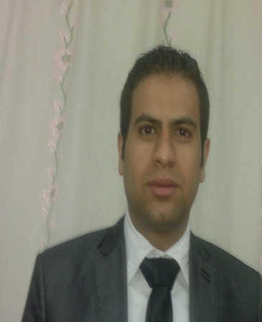

EDUCATION
Sep 2005 – June 2010 Assiut University, Faculty of Engineering
Bachelor of Electrical Engineering “Power and Machine” section
Grade: Excellent with Honor 85.85%
Rank: 2nd
Project: "Applications of plc"
Project Grade: Excellent

WORK EXPERIENCE
March 2012 _ now Faculty of Engineering Assiut University
Position: Teaching Assistant
Responsibilities:
• M.Sc. Researcher in the field of Power system (Renewable energy)

• Provides a demonstration for students in the following subjects.

Electric Circuit Theory (1) Electric Circuit Theory (2)
Power Electronic Circuits Electric Machines
Power System Analysis Power Systems Voltage Stability
Power Systems Power Quality Power System Control
• Participates in Final year graduations projects.
Improvement of Egyptian Electric Network

RESEARCH INTERESTS
- Renewable Energy.
- The Energy management of energy storage systems for microgrid and electrical vehicle applications
- Electrical Power Industrial Application.
- Wind energy conversion systems.
- Control System Using PIC and DSP Controller.
- Utility interactive power conditioner for renewable energy sources.
- Stand-alone and grid connected PV systems.
- Anti-islanding algorithms for grid-connected solar photovoltaic systems.
- Soft switching DC-DC power converter topologies.
- High frequency inverters and power factor correction.
- Protection and control of microgrid and smart grid.

PUBLICATIONS

LANGUAGES
ENGLISH LANGUAGE PROFECIENCY TEST (ELPT) SCORE REPORT 94%
Listening Comprehension: 24
Reading Comprehension : 25
Grammar and structures : 25
Writing: 20
Total: 94
.

Communication and Presentations Skills
International conferences Speaking
I have presented my papers in the following international conferences
- IEEE Middle East Power System Conference (MEPCON’2009), Assiut, Egypt.
- IEEE Middle East Power System Conference (MEPCON’2014), Cairo, Egypt.

TECHNICAL SKILLS
- Matlab & Simulink
- PSCAD Simulation
- PSIM
- Microsoft Office
- FORTRAN 95
- C++

SOFT SKILLS
Attended the following Workshops in Assiut University Faculty and Leadership Development Project (FLDP)
- Communication Skills
- Effective Thinking
- Effective Teaching
- Effective Presentation
- Science Publication

